**1)We need Abstract**

Creating machines that behave and work in a way similar to humans is the objective of artificial intelligence (AI). In addition to pattern recognition, planning, and problem-solving, computer activities with artificial intelligence include other activities. A group of algorithms called “deep learning” is used in machine learning. With the aid of magnetic resonance imaging (MRI), deep learning is utilized to create models for the detection and categorization of brain tumors. This allows for the quick and simple identification of brain tumors. Brain disorders are mostly the result of aberrant brain cell proliferation, which can harm the structure of the brain and ultimately result in malignant brain cancer. The early identification of brain tumors and the subsequent appropriate treatment may lower the death rate. In this study, we suggest a convolutional neural network (CNN) architecture for the efficient identification of brain tumors using MR images. This paper also discusses various models such as ResNet-50, VGG16, and Inception V3 and conducts a comparison between the proposed architecture and these models. To analyze the performance of the models, we considered different metrics such as the accuracy, recall, loss, and area under the curve (AUC). As a result of analyzing different models with our proposed model using these metrics, we concluded that the proposed model performed better than the others. Using a dataset of 3264 MR images, we found that the CNN model had an accuracy of 93.3%, an AUC of 98.43%, a recall of 91.19%, and a loss of 0.25. We may infer that the proposed model is reliable for the early detection of a variety of brain tumors after comparing it to the other models.

2)Need more matter in Introduction (In the Provided document there is only 2 Paragraphs. Use this document as reference

The brain, which is the primary component of the human nervous system, and the spinal cord make up the human central nervous system (CNS) [1]. The majority of bodily functions are managed by the brain, including analyzing, integrating, organizing, deciding, and giving the rest of the body commands. The human brain has an extremely complicated anatomical structure [2]. There are some CNC disorders, including stroke, infection, brain tumors, and headaches, that are exceedingly challenging to recognize, analyze, and develop a suitable treatment for [3].

A brain tumor is a collection of abnormal cells that develops in the inflexible skull enclosing the brain [4–6]. Any expansion within such a constrained area can lead to issues. Any type of tumor developing inside the skull results in brain injury, which poses a serious risk to the brain [7,8]. In both adults and children, brain tumors rank as the tenth mostprevalent cause of death [9]. There are many different types of tumors, and each one has extremely low survival rates based on the texture, location, and shape [10–12].

Around 250,000 people are affected by brain tumors every year, with 2% of those cases being confirmed as malignancies [13]. The predicted number of adults in the United States with a brain tumor in 2020 was 23,890, with 13,590 men and 10,300 women. In 2020, 1879 reported cases of brain cancer were anticipated to be diagnosed in Australia. Every year, 14.1% of Americans are affected by primary brain tumors, of which 70% are children. Although there is no early therapy for primary brain tumors, they do have long-term negative effects [14,15]. Brain tumor cases increased significantly globally between 2004 and 2020 from nearly 10% to 15%

There are about 130 different forms of tumors that can affect the brain and CNS, all of which can range from benign to malignant, from exceedingly rare to common [5]. The 130 brain cancers are divided into primary and secondary tumors

1.Primary brain tumors: Primary brain tumors are those that develop in the brain. A primary brain tumor may develop from the brain cells and may be encased in nerve cells that surround the brain. This type of brain tumor can be benign or malignant.

2. Secondary brain tumors: The majority of brain malignancies are secondary brain tumors, which are cancerous and fatal. Breast cancer, kidney cancer, or skin cancer are examples of conditions that begin in one area of the body and progress to the brain. Although benign tumors do not migrate from one section of the body to the other, secondary brain tumors are invariably cancerous.

A study stated that brain tumors are responsible for about 85–90 percent of all significant CNS tumors [20]. To drastically lower the fatality rate from brain tumors, early identification is important [21]. Medical experts have significantly utilized medical imaging for tumor identification [22]. One of the most-popular methods for the early diagnosis of brain tumors is magnetic resonance imaging (MRI) [23]. Radiologists routinely manually detect brain tumors [24].

The amount of time it takes to grade a tumor depends on the radiologist’s skill and experience. However, the process of identifying a tumor is imprecise and expensive. A patient’s odds of survival can be significantly lowered by misdiagnosing a brain tumor, which can result in serious problems. The MRI technique is becoming more and more popular as a solution to address the limitations of human diagnosis.

In the healthcare industry, deep learning is frequently utilized for analysis, classification, and detection . The first time the CNN was utilized was in 1980 . The CNN’s computing capacity is based on a model of the human brain. Humans notice and recognize objects based on their outward appearance. Similar in operation, the CNN is renowned for processing images. Some of the most well-known CNN models include ResNet (152 layers), GoogLeNet (22 layers), AlexNet (8 layers), and VGG (16–19) [31–33].

**3)Detailed description of Data preprocessing steps we used in the code.**

Pre-processing is an essential stage, where the data are processed to make them usable for training purposes. Since the MR images were obtained from a patient database, they were not clear and low-quality. In order to prepare our images for further processing, we normalized them at this stage. In order to smooth the images and remove the blurred images from the original images, the authors also used Gaussian and Laplacian filters.

Data Division and Augmentation

Our dataset was small and only included MR images, but deep neural networks require a large dataset to produce promising results. Our dataset included a total of 2870 MR images, with 80% of the data used for training and the remaining images used for testing and validation at a rate of 10% and 10%, respectively. The amount of the original data can be increased by augmentation, and then, the training can be improved. Additionally, this enhances the model’s capacity for learning. Therefore, we performed data augmentation by mirroring the MR images and applied rotation, width and height shifting, and zooming. The datasets were then validated using the holdout validation method.

Validation Process

For the dataset of the 2870 scan images, it was critical to choose the best validation procedure. We used a holdout validation process, keeping 80% of the data for training and 20% for testing. The holdout validation technique is the most-commonly used method and produces effective results . The holdout method typically involves splitting the dataset into two parts: a training set and a testing set, which helps the model train faster. The training set was used to train the deep learning model, while the testing set was used to evaluate the model’s performance. In the holdout method, 80% of the dataset was randomly selected to be used as the training set, and the remaining 20% was used as the testing set. The model was trained on the training set and then evaluated on the testing set to estimate its performance. The advantage of using 80% of the data for training is that the model has more data to learn from, which can help it generalize better to new, unseen data. However, the testing set is not representative of the overall data, so the performance estimate may be biased.

**4)Detailed description of CNN models steps like about layers and activation function**

**Proposed Architecture**

In our study, an input image with a size of 32 × 32 pixels was sent to an initial convolutional layer with 16 filters, a 32 × 32 × 16 feature map, and a kernel size of 3 × 3 in order to search for the most-generic features. The convolutional layer’s output was then forwarded to a max-pooling layer feature map of 15 × 15 × 16 to decrease the size of the spatial data for the subsequent layer by half. The max-pooling procedure selected the greatest number of elements or pixels from the feature map area that the filter has covered. This result was then fed to a further convolutional layer with filter values of 32 and a 13 × 13 × 32 feature map with a 3 × 3 kernel size. After that, the output was then forwarded to the max-pooling layer feature map of 6 × 6 × 32 to cut the amount of spatial data for the next layer in half. Another convolutional layer and another pooling layer came next. The feature map of 4 × 4 × 64 in size was made up of 64 filter values and a kernel size of 3 × 3 in the final convolutional layer, while the final pooling layer had a feature map of 2 × 2 × 64. The newly created 4160-dimensional fully connected dense layer received the flattened final output of the previous convolutional layer. This output was sent to the final output layer, which included a softmax activation function. While the last layer employed a softmax activation with no dropout for the output, all the other layers utilized a dropout of 0.5 with a ReLU activation function. The above-proposed CNN architecture’s configuration is depicted in Figure 2. The model was trained, validated, and tested using 80 epochs, a batch size of 18, and a learning rate of 0.01. Along with the Adam optimizer, a categorical cross-entropy-based loss function was calculated to find the loss value.

The methodology is divided into a few important stages. First, we collected our data from an available then we pre-processed our datasets. We used the holdout validation system in the validation stage. We applied various machine learning models to train our images. Our dataset was split into three groups: 80% for training, 10% for testing, and 10% for validation. We tried to validate four different types of brain images: glioma tumors, meningioma tumors, no tumor, and pituitary tumors. Then, in order to validate our findings, we considered several types of metrics including the accuracy, recall, AUC, and loss. Figure shows the step-by-step breakdown of this research

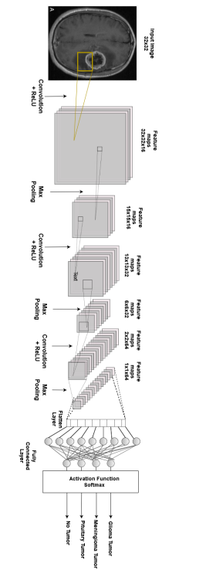

Dataset Collection

We obtained the dataset from publicly accessible online data on kaggle.com to detect brain tumors [45]. Images from magnetic resonance imaging (MRI) were used to construct the dataset. We selected MR images for our research since MRI is the best technique for detecting brain tumors. Meningioma (937 photos), no tumor (500 images), pituitary tumor (900 images), and glioma tumor (926 images) were the four different types of brain tumor data that we used in our study. In total, we used 3264 MRI data in our dataset. Table 2 displays the breakdown of the dataset

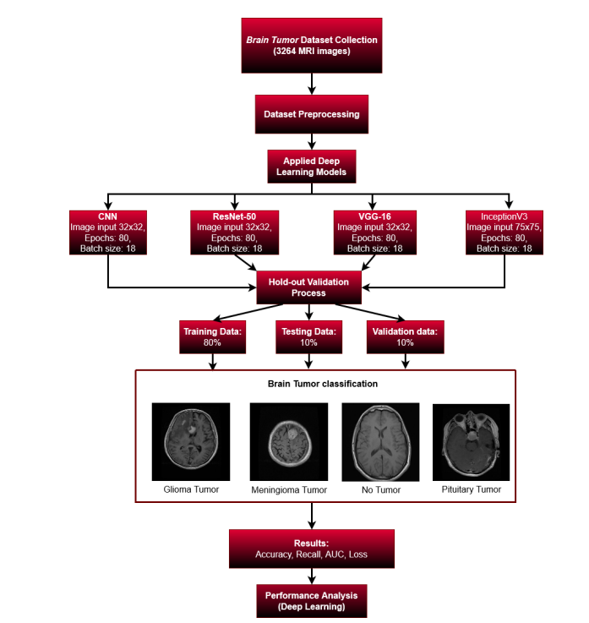

**5) Need more information in conclusion too.**

Early detection of brain tumors can play a significant role in preventing higher mortality rates globally. Due to the tumor’s form, changing size, and structure, the correct detection of brain tumors is still highly challenging. Clinical diagnosis and therapy decisionmaking for brain tumor patients are greatly influenced by the classification of MR images. Early brain tumor identification using MR images and the tumor segmentation method appear promising. Nevertheless, there is still a long way to go before the tumor location can be precisely recognized and categorized. For the purposes of early brain tumor detection in our study, we used a variety of MRI brain tumor images. Deep learning models also have a significant impact on classification and detection. We proposed a CNN model for the early detection of brain tumors, where we obtained promising result using a large amount of MR images. We employed a variety of indicators to ensure the efficiency of the ML models during the evaluation process. In addition to the proposed model, we also took into account a few other ML models to assess our outcomes. Regarding the limitations of our research, as the CNN had several layers and the computer did not have a good GPU, the training process took a long time. If the dataset is large, such as having a thousand images, it would take more time to train. After improving our GPU system, we minimized the training time. Future work can be performed to better correctly identify brain cancers by using individual patient information gathered from any source.